SQL Server – Query Designer for TSQL Code

Tips and Hints:

**Use the Query Designer to build complex queries across multiple tables without writing any code.**

SQL Server Management Studio SSMS includes the **Query Designer** to assist in building queries. It is a visual tool that allows you to select the tables and columns you want in your query, as well as any filtering criteria.

**No need to write any SQL code — the Query Designer will generate that for you.**

## Use the Query Designer to Build a Simple Query

The following is a Demo of using the **Query Designer** to build a simple query. If you've been following **SQL Server Quick Guides** you will now have a database with three tables — all of which contain data. with established relationship between these tables, we can now run queries across all three, returning related records.

1. **Open the Query Designer**

Open a new query window by clicking on New Query in the toolbar.

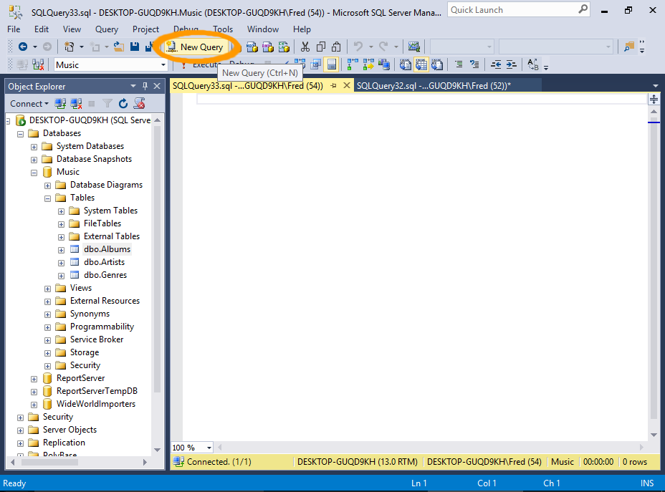

**Step1:** click on the **New Query** icon in **SSMS.** Make sure you have selected the correct Database

**Step10:** In Word Adjust and Maximize the Database Diagram Image

Adjust the Word document to maximize the database diagram image.  Change the margins to .5 inch, enter the image and resize it to enlarge. Below is a snippet from a Word document Database Diagram.

Open a new query window by clicking on New Query in the toolbar.

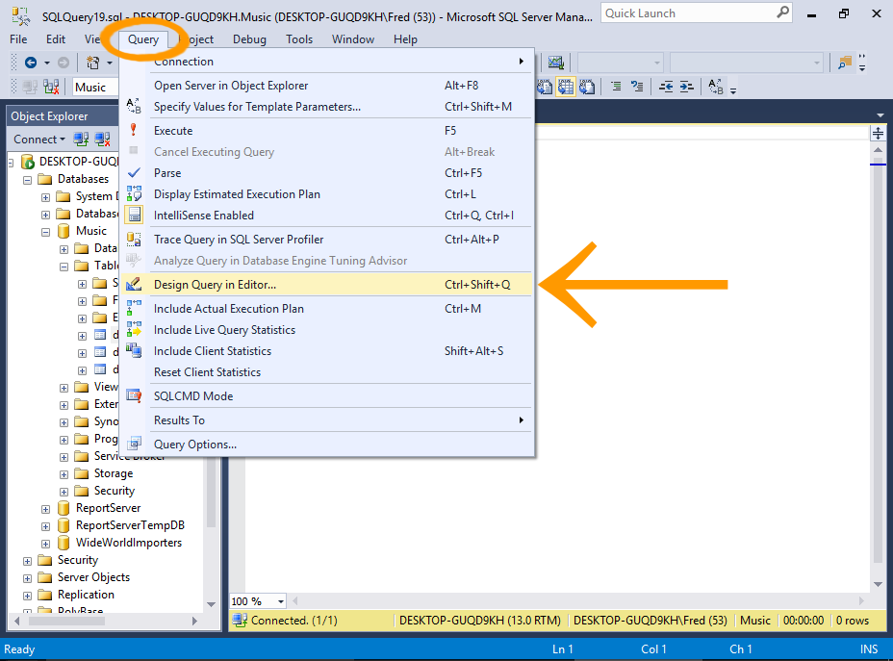

**Step2:** Select **Query** > **Design Query in Editor**... from the top menu.

If you can't see the Query option in the top menu, click inside the query window first. This will change the top menu items to be query-related options.

Alternatively right click the white Query Window pane for the Query menus.

1. **Add the Tables**

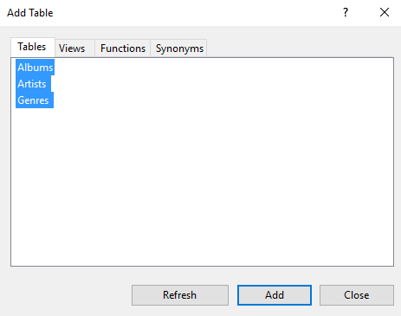

**Step 4:** Here, you select which **Tables** you'd like in your Query. The example covers the 3 tables from the SQL Server Quick Guides. You may practice with any of the sample tables provided.

Lab 01 – only working with 1 table

Lab 02 – working with many related Tables

**In the example I have Select all three and click Add.**

Click Close to close the dialog box.

1. **Design the Query**

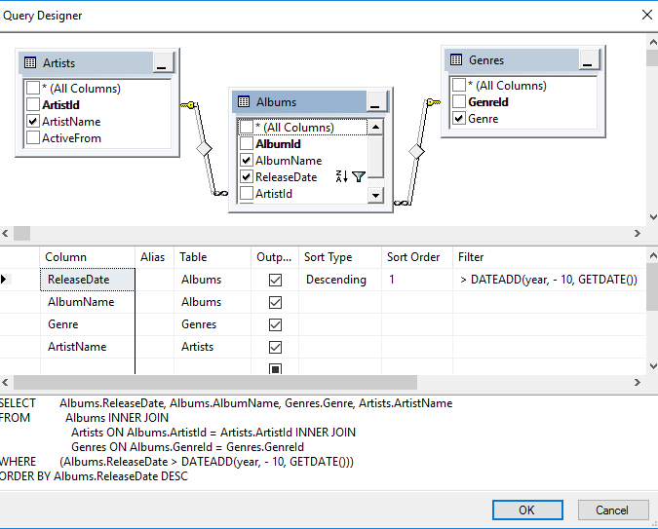

The above Query Window shows how to obtain related information from 3 Tables.

You will now see the selected tables, and their relationships, in the **Query Designer**.

Feel free to click and drag them around to provide a better visualization of their relationship with each other.

You can also re-size each pane by clicking its edge and dragging it up or down.

## How to Design a Query

In the top pane (the Diagram Pane), click each column that you want to include in the query (whether you want to display it or not). Each column you select in the top pane will automatically appear in the middle pane.

In the middle pane (the Grid Pane or Criteria Pane), use the Output checkbox to indicate which columns will be returned in the results. Use Sort Type to specify the order of the results by a given column. You can use Sort Order to specify which column will be sorted first, second, etc. Use Filter to add filtering criteria to filter the records returned.

The bottom pane (the SQL Pane) dynamically generates the SQL statement that your query produces. This is the statement that will be run when you close the Query Designer and execute the query.

## Our Example

In our example, our query will return all **albums** (along with their genre, artist, and genre) that were released in the last ten years. The criteria to achieve this is **>DATEADD(year, - 10, GETDATE())**.

The query will sort the results by the release date in descending order.

Here's a close-up of the Criteria Pane:

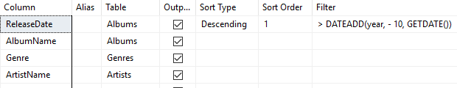

You can change the order of the columns by clicking and dragging them up or down.

If you're reading this long after this tutorial was written, you might need to adjust the criteria to go back 20 years or more before you get any results.

Alternatively, you could add something a bit more modern to the music collection :)

Make sure you keep this query open in the query window because next, we will save it as a view in the next Quick Guide.

Wrap Up

Let Query Designer scale plausible solutions. Copy and paste the TSQL Code and develop **.sql** files demo files similar to the ones you are using in the Demos and Labs.